Kindly download this folder in C drive because without that you cant change drive in Command prompt as Run as admin  
  
Then run Querry given below

Database-Level Permissions:

=>Navigate to the database where your application needs access.

=>Expand the "Security" folder within the database.

=>Expand the "Users" folder to view a list of users.

=>Ensure that the NT AUTHORITY\SYSTEM login is listed as a user in the database. If not, you may need to create a user for the login and map it to the appropriate database roles.

=>Right-click on the user corresponding to the NT AUTHORITY\SYSTEM login and select "Properties".

=>In the "Membership" tab, ensure that the user is a member of the necessary database roles (e.g., db_owner, db_datareader, db_datawriter, etc.). These roles determine the level of access the user has within the database.

Click "OK" to save any changes made.

quries run:

cd C:\Users\DESK_003\Desktop\SongViewUpdaterService\bin\Debug\net7.0

C:\Users\DESK_003\Desktop\SongViewUpdaterService\bin\Debug\net7.0>SongViewUpdaterService.exe install

C:\Users\DESK_003\Desktop\SongViewUpdaterService\bin\Debug\net7.0>SongViewUpdaterService.exe start

C:\Users\DESK_003\Desktop\SongViewUpdaterService\bin\Debug\net7.0>SongViewUpdaterService.exe stop

C:\Users\DESK_003\Desktop\SongViewUpdaterService\bin\Debug\net7.0>SongViewUpdaterService.exe uninstall

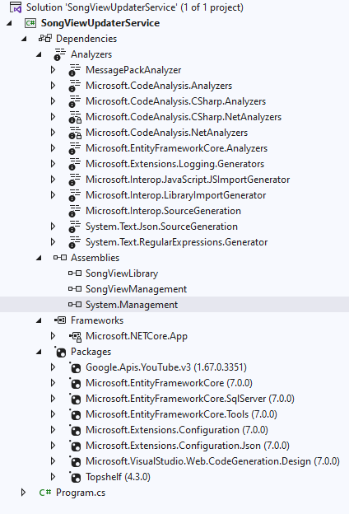

Here you can add these 2 dependencies from SongViewManagement project via   
  
Song view Management\SongViewManagement\bin\Debug\net7.0 => SongViewManagement.dll   
  
Song view Management\SongViewManagement\bin\Debug\net7.0 => SongViewLibrary.dll